Impractical Deep Learning for Coders

* Implement much of fastAi from **Foundations**
* Basic matrix Calculus, Train loops with Callbacks, custom Optimizer, custom annealing, regularization, data loader and blocks
* Lots of layers and architectures
* Jupyter dev, testing and docs
* Read **Papers** and implement them, we even do some research
* Learn Object Detection Seq2Seq/Attention, Transformer/XL, CycleGan, Audio ..
* Performance: distributed training, JIT, CUDA/C++
* Implement some of fastAi in Swift.

Why Swift ?? We use Swift for TensorFlow

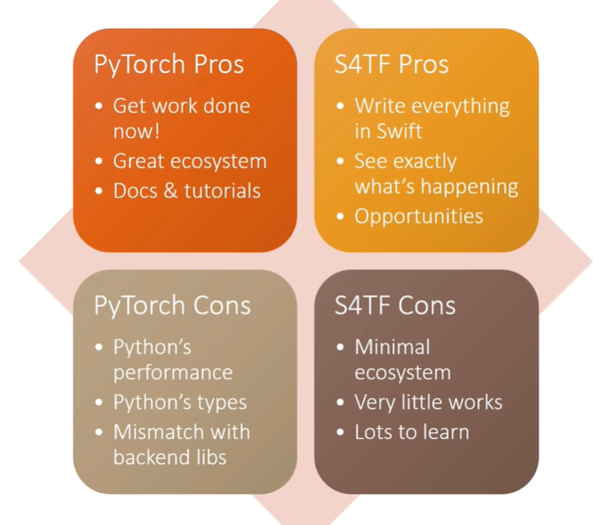

What is meant by Foundations ?

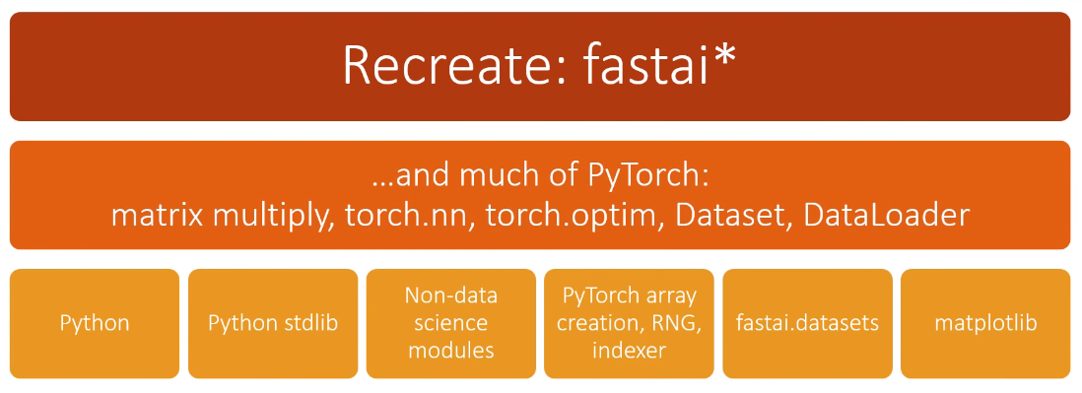

Why?

